Post 16 Enrichment


A levels is so much more than just your academic qualifications. In sixth form, we believe in developing the whole person as we want you to achieve your full potential in and out of the classroom. As a sixth form student, you will have the opportunity to take part in our extensive enrichment program, this includes a wide range of career and life enhancing activities, clubs and societies.

Why do Enrichment Activities?
Enrichment teaches you new skills and builds on your existing subject knowledge to make you stand out from the crowd when applying for university, apprenticeships or employment. It is also a great way for you to make new friends and have fun. Key skills that both employers and universities are looking for include:

We work with students to support their development of transferable skills and competences for higher education and future careers.

Enrichment activities allow you to develop all round interests, improve on your transferable skills and give you outlets to improve mental and physical health.

Enrichment Pathways

The expectation in Year 12 is that students work to complete at least the minimum a Vocational enrichment pathway. There are also Traditional, Challenge or Elite awards for those students wanting to demonstrating higher student engagement and skills at a higher standard. Academic Awards are qualifications and offer UCAS Points. Each pathway can be tweaked to individual achievements – if it’s not listed, ask us which pathway your hobby might fall into.

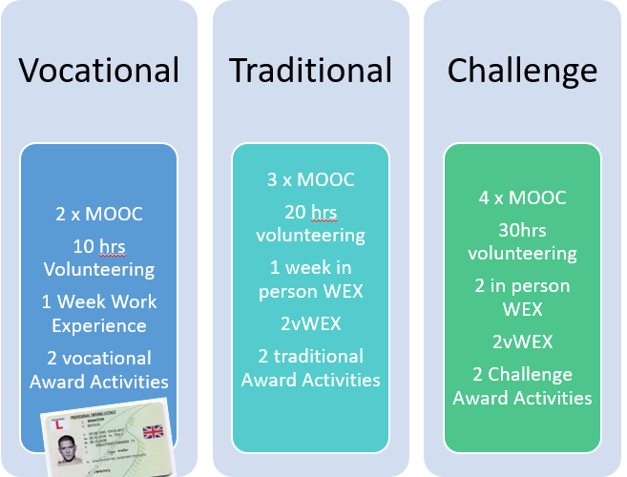
The Pathways

These academic Pathway can be done in conjunction with any of the above awards.

Elite Pathway
Additional recognition for
High level sporting achievement OR
Committed and continued leadership in an out of school activity OR
Excellence in performing or other arts OR
Completion of Duke of Edinburgh gold award OR
Achievement of high rank in any branch of cadets or St John Ambulance

ACADEMIC AWARD ENRICHMENT ACTIVITIES
Completion of the EPQ
Completion of qualification (GCSE/A level/Music grading) outside school
Completion of AS Finance Course
Completion of AS RE Course

The Extra Benefits

On top of the enrichment program all students will have the following:

*Once the Vocational Pathway has been achieved we will pay for a driving license application

The value of Enrichment for YOUR future goals

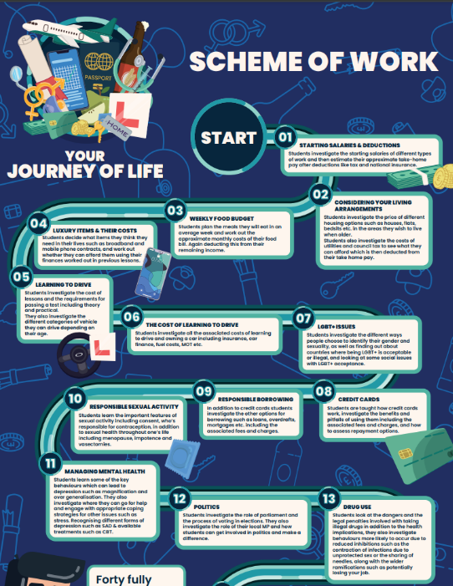
The Journey of Life – 1 hour timetabled session per fortnight


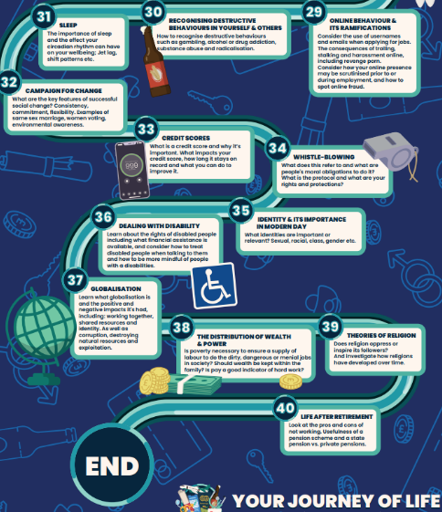

Whole Post 16 Enrichment Days

Over your time in post 16 you will have opportunities for trips, external UCAS events, social events and ‘enrichment’ days which will contribute to each award as well as he things listed below.

When we tell you about each event, we will let you know what award it is for and whether it is compulsory (Vocational) or optional (Traditional/Challenge)

Evidencing Your Enrichment

Your tutors will be talking to you in the Autumn Term to establish what enrichment you are taking part in and what evidence you will be able to provide. Evidence forms will be available through tutors who will help you to fill them out and when completed they will be passed to the Post 16 Team who will verify them and issue the Awards achieved.

Tutor Support

Once every half term your Tutors will review your enrichment activity progress and planning during your Tutor session. This will support you in tracking, recording and providing evidence for your Enrichment activities to include on your applications for your next steps. It also helps your tutor
write a well-rounded reference for UCAS and apprenticeships

What next?

- Decide on your enrichment activities
- Sign up for the EPQ by December if year 12
- Fill in your enrichment timesheet
- Talk to your tutor about what you might do for your Vocational award (minimum)
- Keep an eye out on your e mail for in school volunteering opportunities
Enrichment Activity Details
Remember that other enrichment activities not listed here can be recognised as part of each level of award. It is important that you let your tutor know anything you do outside school which could be celebrated and recognised.
In order to qualify and evidence your enrichment for your awards please see the details below:

Type | Pathway Level | Time Commitment | Description | Outcomes | Evidence
Work Experience | Vocational  Traditional  Challenge | 1 Week  1 in person 2 vWEX  2 in person WEX + 2vWEX | A short term placement with an employer, to observe and work alongside people as they go about their daily tasks. You will develop skills, contacts, and learn more about the kind of career you would like to do. | Gain self-awareness, communication to support and demonstrate key skills for applications for university, apprenticeships and employment. | Enrichment paper work sign off.
Volunteering | Vocational  Traditional  Challenge | 10 hours  20 hours  30 hours | Volunteering organised by yourself. For example teaching (unpaid) dance classes, helping at Scouts or Brownies/Guides. Volunteering in a shop such as Compton. Charity work. | Gain self-awareness, communication to support and demonstrate key skills for applications for university, apprenticeships and employment. | Enrichment paper work sign off.
Christian Ethos | Vocational  Traditional  Challenge | 10 hours? Or events  20 hours?  30 hours? |  |  | Enrichment paper work sign off.
Life skills Mentor | Vocational  Traditional  Challenge | 10 hours  20 hours  30 hours | Work with the SEND team to support KS3/KS4 students with aspects of life admin. Based on ‘They Don’t teach this at School’ book. | Gain self-awareness, communication to support and demonstrate key skills for applications for university, apprenticeships and employment. | Enrichment paper work sign off.
Sports Sanctuary | Vocational  Traditional  Challenge | 10 hours  20 hours  30 hours | Work with the SEND team to support KS3/KS4 students with developing their gross motor skills. | To support fine and gross motor skills for Pupils. Following a program that incorporates the NHS support for balance and handwriting program and using SWITCH for physical and brain based activities. | Enrichment paper work sign off.
Homework Club | Vocational  Traditional  Challenge | 10 hours  20 hours  30 hours | Work with the SEND team to support KS3/KS4 students with completing their homework. | Supporting Individual Pupils academic studies and well-being either before or after school, with Homework, Reading, Lego and Chess. | Enrichment paper work sign off.
Gardening Support | Vocational  Traditional  Challenge | 10 hours  20 hours  30 hours | Work with the SEND team to support KS3/KS4 students with improving the environmental quality of the school site.. | To foster well-being and encourage a life skill using nature. A mix of vegetable growing and aesthetics based around the environmental area. | Enrichment paper work sign off.
Exercise for Health | Vocational  Traditional  Challenge | 10 hours  20 hours  30 hours | Utilise the St Regis fitness suites to improve your health. Research shows that physical activity can also boost self-esteem, mood, sleep quality and energy, as well as reducing your risk of stress. | Reduce stress, show commitment | Enrichment paper work sign off.
Forces Activity | Vocational  Traditional  Challenge  Elite | 10 hours  20 hours  30 hours  40 hours | Cadet Force’s activities you already participate in regularly can be recognised as contributing to Vocational, Traditional or Challenge awards. You may wish to join as a Cadet in any of the Forces. | Develop skills and work towards achievements to showcase on your applications and at interview | Enrichment paper work sign off.
School Sports Team | Vocational  Traditional  Challenge  Elite | 10 hours  20 hours  30 hours  40 hours | The school sports teams such as football or basketball you already participate in regularly can be recognised as contributing to Vocational, Traditional or Challenge awards. | Develop skills and work towards achievements to showcase on your applications and at interview | Enrichment paper work sign off.
Out of school Sports Team | Vocational  Traditional  Challenge  Elite | 10 hours  20 hours  30 hours  40 hours | Any out of school sports teams such as football or basketball, athletics that you already participate in regularly can be recognised as contributing to Vocational, Traditional or Challenge awards. | Develop skills and work towards achievements to showcase on your applications and at interview | Enrichment paper work sign off.
MOOC’s | Vocational  Traditional  Challenge | 2 MOOC’s completed  3 MOOC’s completed  4 MOOC’ completed | MOOCs are Massive Open Online Courses, short-term and bite-sized, offered by universities nationally and internationally. They are a free and flexible way to study with top educators, covering a vast array of topics and an insight into studying for a degree. https://www.futurelearn.com/courses | Develop independent study skills, gain knowledge in a specialist, degree relevant area of study, demonstrate your interest and ability in studying for your degree | Copy of completed certificate
Student Ambassador | Vocational  Traditional  Challenge | 2 events  3 events  4 events | Represent the academies at events including Open Days and Progress/Parents Evenings, as well as student voice, campus tours etc. This may also extend to student leadership activities including organising and running fundraising and community events such as a Christmas Fair or post 16 social events | Develop a variety of skills, such as team work, organization, communication and time management. Contribute to the community | Completed Volunteering booklet: time record, self-assessment, supervisor reference and sign-off
Subject Support | Vocational  Traditional  Challenge | 10 hours  20 hours  30 hours | Academic mentoring in classrooms of lower years, in any subject.  NB – GCSE grades 5 subject supporting required. | Develop mentoring skills, embed own subject knowledge through explaining to others, demonstrate communication, interpersonal and organisational skills | Enrichment paper work sign off.
Pathway Ambassador | Vocational  Traditional  Challenge | 2 events  3 events  4 events | Represent the career pathway at events including Open Days and Progress/Parents Evenings, as well as student voice, campus tours etc. This may also extend to student leadership activities including organising and running fundraising and community events such as a Christmas Fair or post 16 social events | Develop a variety of skills, such as team work, organization, communication and time management. Contribute to the community | Completed Volunteering booklet: time record, self-assessment, supervisor reference and sign-off
Bloom Wellbeing program | Traditional | : 6 x 1 hour sessions (online or classroom based TBC) | A program of personal development workshops (small groups of 15) aimed at equipping you with tools to build resilience, emotional wellbeing and find balance in your transition into A Level Study and your future next steps. | Learn about wellbeing, work life balance, personal development | Staff sign-off, complete Enrichment form
NCS | Challenge  Elite | 1 NCS program  2 NCS programs | Build your independence. Boost your work-readiness. Make a positive impact on the world. Blossom in confidence. And form some amazing friendships along the way. And the best bit? You can do it all away from home, online, or in your local community. Whatever suits you best. | Develop skills and gain experience to showcase on CVs and applications. Personal and social development. | NCS Certificate
TEFL | Challenge |  | Awaiting response from TEFL
Reading Buddy | Vocational  Traditional  Challenge | 10 hours  20 hours  30 hours | Working with students lower down the school, you will volunteer some of your time in study periods and form times, to listen to younger students read. You will engage them in talking about reading and offer support for them if they are struggling. | Develop skills and gain experience to showcase on CVs and applications. Personal and social development. Giving something back to the school community | Enrichment paper work sign off.
Elite Sporting activity | Elite | n/a | If you are a sportsperson competing at County or GB level then we are able to acknowledge this level of commitment and training with a Elite Enrichment Award. | To showcase on all Post 18 applications, demonstrating hard work, dedication and commitment. | Enrichment paper work sign off.
Cadet Ranking Officer | Elite | n/a | If you are a Cadet Ranking Officer with any of the Forces, we are able to acknowledge this level of commitment and training with a Elite Enrichment Award. | To showcase on all Post 18 applications, demonstrating hard work, dedication and commitment. | Enrichment paper work sign off.
Night Course | Academic | n/a | For example undertake a college course as an evening class, for example we have had students undertake courses in plumbing/ welding etc | Extra qualifications to support Post 18 choices. | Certification
EPQ | Academic | Yearly scheme of lessons | Working to an assessment criteria and with guidance from a tutor, you will set your own question to investigate and learn how to research and write-up your project. You have the scope to research any area that interests you and you will need to present your work to the group. | Qualification equivalent to half an A Level, UCAS Tariff Points | Certification
AS Finance Course (Y13) | Academic | Yearly scheme of lessons | A timetabled series of lessons. When you will sit two final exams that lead to a L3 qualification (AS) that holds UCAS points and recognised by all Post 18 pathways. | Qualification equivalent to half an A Level, UCAS Tariff Points | Certification
AS RE Course | Academic | Yearly scheme of lessons | A timetabled series of lessons. When you will sit two final exams that lead to a L3 qualification (AS) that holds UCAS points and recognised by all Post 18 pathways. | Qualification equivalent to half an A Level, UCAS Tariff Points | Certification
Music Grading | Academic | Yearly scheme of lessons | Timetabled lessons which are run by in school or external music schools that have a recognised Grade 1-8 status | Qualification, that in some cases leads to UCAS points. | Certification
D of E | Vocational  Traditional  Challenge | Vocational Award  Traditional Award  Challenge Award | Achieving an Award will give you skills, confidence and an edge over others when you apply for college, university or a job. Beyond your academic achievements, universities want to see evidence of so called ‘soft skills’ that you have developed through extra-curricular activities, such as communication, commitment, leadership and teamwork. | To showcase on all Post 18 applications, demonstrating hard work, dedication and commitment. | Certification
Barclays Life skills | Traditional | https://barclayslifeskills.com/sign-in/young-person/ | LifeSkills, created with Barclays, helps young people get the skills and experiences they need to enter the world of work. | Completion of life skills money matters. To inform you of future budgeting and financial responsibilities. | Certification
Lunch Duties | Vocational  Traditional  Challenge | 1 Term  2 terms  3 terms | To support the staff body to ensure that the school is safe during lower school unstructured time. To be the eyes and ears to monitor what is going on around school. | To demonstrate your leadership, and communication skills to be proactive and deal with potentially challenging situations. | Enrichment paper work sign off.
Speaker Events | Vocational  Traditional Challenge | 3 Events  5 Events  6 Events | To attend a variety of key speaker events in school which cover a wide range of topics. | To have a wide range of events that you can draw on and talk about in Post 18 applications and personal statements. | Enrichment paper work sign off.
Student Leadership | Traditional  Challenge | Prefect - Yearly  HB/HG - Yearly | To lead and support the student leadership team across the school. | To demonstrate your leadership, communication, organisational skills to drive change. | Enrichment paper work sign off.

