Moral, World and Religious Views Programme
2024-25

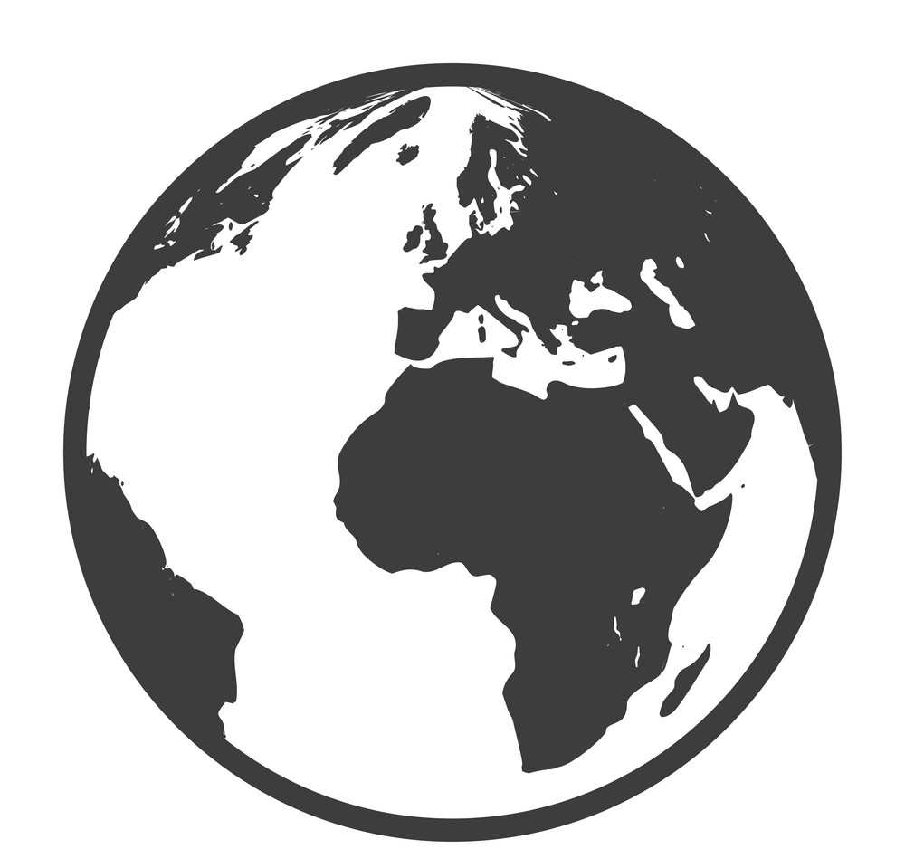


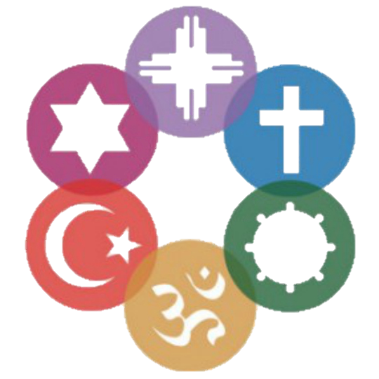

Contents

Week | Date | Theme | Linked Event
Week 1 | 9/9 | Mental Health | 10th September | World Suicide prevention day
Week 2 | 16/9 | Democracy | 15th September | International day of Democracy
Week 3 | 23/9 | Organ Donation | All week | Organ donation week
Week 4 | 30/9 | Food waste | 29th Sept | International Day of Awareness of Food Loss and Waste
Week 5 | 7/10 | Neuro Diversity | All Month | ADHD Awareness Month
Week 6 | 14/10 | First Aid | 16th October | Restart a Heart Day
Week 7 | 4/11 | Health | 6th November | National Stress Awareness Day
Week 8 | 11/11 | Pets | 2nd week in Nov | Human Animal Relationship Awareness Week
Week 9 | 18/11 | Men | 19th November | International Men’s Day
Week 10 | 25/11 | Food ethics | All Month | World Vegan Month
Week 11 | 2/12 | Charity | All Month | Decembeard
Week 12 | 9/12 | Migration | 18th December | International Migrants Day
Week 13 | 16/12 | Christmas in other cultures | 25th December | Christmas
Week 14 | 6/1 | Reflection and resolutions | 1st January | New Years Day
Week 15 | 13/1 | Religion | 15th January | World Religion Day
Week 16 | 20/1 | Education | 24th January | UN International Day of Education
Week 17 | 27/1 | Chinese New Year | 29th January | Chinese New Year
Week 18 | 3/2 | Health | 4th February | World Cancer Day
Week 19 | 10/2 | Internet Safety | 11th February | Safer Internet Day
Week 20 | 24/2 | Discrimination | 1st March | UN Zero Discrimination Day
Week 21 | 3/3 | D(d)eafness | 3rd March | World Hearing Day
Week 22 | 10/3 | Health | 12th March | National no smoking day
Week 23 | 17/3 | Happiness | 20th March | UN International day of happiness
Week 24 | 24/3 | Gender Equality | All Month | Women’s’ History Month
Week 25 | 31/3 | Stress | All April | Stress Awareness Month
Week 26 | 21/4 | Chernobyl | 27th April | International Chernobyl Remembrance Day
Week 27 | 28/4 | Physical Activity | All Month | National Walking Month
Week 28 | 5/5 | War and Peace | 8th May | Anniversary of VE Day
Week 29 | 12/5 | Vesak | 12th May | Vesak (Buddhist Festival)
Week 30 | 19/5 | Culture | 21st May | UN Cultural Diversity Day
Week 31 | 2/6 | Environment | 8th June | World Oceans Day
Week 32 | 9/6 | Child Labour | 12th June | World Day Against Child Labour
Week 33 | 16/6 | Windrush | 22nd June | Windrush Day
Week 34 | 23/6 | Roma | All month | Gypsy Roma Traveller History Month
Week 35 | 30/6 | Fair Trade | 7th July | World Chocolate Day
Week 36 | 7/7 | Population | 11th July | World Population Day
Week 37 | 14/7 | Communication | 17th July | World Emoji Day
Week 38 | 21/7 | Self Care | 24th July | International Self Care Day

What’s it all about?

This booklet is designed to let you reflect on important moral, world and religious issue and therefore become more informed and articulate about the world you live in.

The themes change weekly and are linked to a religious or cultural event.

You will be invited to do some tasks on each subject before taking part in a discussion or debate topic. This is a key critical thinking skill and will help with any interviews you may have in the future.

Each session ends with a time for reflection. This can be form a religious or non-religious perspective – you choose which suits you!

Content Warning


Each theme is laid out in the Contents (above). We are aware that some of the issues may be sensitive to some of you. If you feel you cannot complete or participate in any of these sessions, please let your tutor know.

Answers

In tasks where you may need answers, these can be found at the back of this booklet – try the task first though- no peeking!

Mental Health
10th of September is World Suicide Prevention Day. Every year organisations and communities around the world come together to raise awareness of how we can create a world where fewer people die by suicide.
Each year has a different theme and focus, to bring to light a specific aspect of suicide prevention.

Task:

True or False?
Statement | T/F? | Statement | T/F?
4912 suicides were registered in 2020 |  | Suicide is the single biggest killer of men under the age of 45
The North East of England had the highest suicide rate (13.3. per 100,000) in 2020 |  | The male suicide rate for was 15.3 per 100,000* compared to the female suicide rate of 4.9 per 100,000*
Males aged 45-49 have the highest suicide rate (23.8 per 100,000) |  | There were less suicides in 2020 than in 2019.

Case Study: Rocco Hawkins- Bridges of Hope
A Derby man known for spreading messages of hope has been sent grateful thanks from people around the world. Rocco Hawkins caught the attention of many people in the city in April as he walked to bridges to leave handwritten notes of support for those struggling with mental health.
The 37-year-old set up a Facebook group called Bridges of Hope which has already gained more than a thousand members from across the world.
The dad has spoken of the incredible reaction to the quotes has pinned to bridges, with many people getting in touch with him to say he has saved their life.
Rocco, of Spondon, said: “All I wanted to do was use my own experience to try and help save a life. “The amount of messages I've received since starting the bridge work has been incredible. Strangers messaging to tell me that I have saved their life.
“I didn't know what to say or do, I was absolutely overwhelmed, to think that me, a guy that has contemplated not living anymore, now has the strength to stay alive and be able to save someone else.
“Apart from having children, it is the proudest moment of my life.”

Sources of help
Samaritans – for everyone  Call 116 123 | Campaign Against Living Miserably (CALM)  Call 0800 58 58 58 – 5pm to midnight every day or visit the webchat page | Papyrus – for people under 35  Call 0800 068 41 41 – 9am to midnight every day  Text 07860 039967 | Childline – for children and young people under 19  Call 0800 1111 – the number will not show up on your phone bill

Discussion: If you try but fail to commit suicide, should you got to prison?
Reflections:
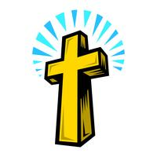  Lord, We pray for those affected by hopelessness as well as people dealing with suicidal thoughts. We ask that you provide them with comfort and guidance, and the placement of a support system in their life to let them know that they are important and that they matter and that they're not alone. | “Sometimes even to live is an act of courage.”  ― Lucius Annaeus Seneca
Democracy
The International Day of Democracy (15th September) provides an opportunity to review the state of democracy in the world.
The values of freedom, respect for human rights and the principle of holding periodic and genuine elections by universal suffrage are essential elements of democracy. In turn, democracy provides the natural environment for the protection and effective realization of human rights.

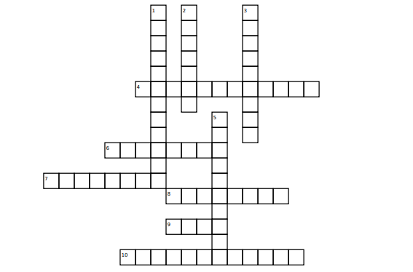
Down:
1. The principles by which an organisation, including a country or a state, is governed (12)
2. Individuals living as members of a community, including the members of a nation (7)
3. a form of government in which people choose leaders by voting (9)
5. (in the UK) the highest legislature, consisting of the Sovereign, the House of Lords, and the House of Commons. (10)
Across:
4. form of government in which one person or a small group possesses absolute power without effective constitutional limitations (12)
6. A Member of Parliament who is a member of the executive government, and who is usually in charge of a government department (8)
7. The choosing of a person or a government by voting (8)
8. a form of government with a king or queen at the head (8)
9. A formal expression of a choice, such as putting one's hand up or marking a piece of paper (4)
10. an area whose voters elect a representative (12)
Discussion: Could dictators ever be good?
Reflections:
We give thanks for the democracy alive in our country and for the freedom to worship You. Help the elected government and all in positions of power and authority to govern wisely and for the common good of all.  Amen | Where you see wrong or inequality or injustice, speak out, because this is your country. This is your democracy. Make it. Protect it. Pass it on.  - Thurgood Marshall
Organ Donation
Organ Donation Week is an annual campaign held in September that aims to encourage people to join the organ donor register and to share their decision with their families.
Right now across the UK, there are around 6,500 people in need of an organ transplant, including around 150 children and teenagers. On average three people die every day in need of an organ transplant because there just aren’t enough organ donors.

Task:
True or False?
Statement | T/F? | Statement | T/F?
Right now across the UK, there are around 4,500 people in need of an organ transplant |  | The kidney is the most commonly transplanted organ in the world
In the UK there are around 150 children and teenagers in need of a transplant |  | There is a shortage of organ donors for and from black and ethnic minority groups.

Case Study: Transplant news
Man gets genetically-modified pig heart in world-first transplant
A US man has become the first person in the world to get a heart transplant from a genetically-modified pig. David Bennett, 57, is doing well three days after the experimental seven-hour procedure in Baltimore, doctors say.
The transplant was considered the last hope of saving Mr Bennett's life, though it is not yet clear what his long-term chances of survival are. "It was either die or do this transplant," Mr Bennett explained a day before the surgery. "I know it's a shot in the dark, but it's my
last choice," he said.
Doctors at the University of Maryland Medical Center were
granted a special dispensation by the US medical regulator to
carry out the procedure, on the basis that Mr Bennett - who has
terminal heart disease - would otherwise have died. He had been
deemed ineligible for a human transplant, a decision that is often
taken by doctors when the patient is in very poor health.
The pig used in the transplant had been genetically modified to
knock out several genes that would have led to the organ being
rejected by Mr Bennett's body, the AFP news agency reports.
For the medical team who carried out the transplant, it marks the culmination of years of research and could change lives around the world. Surgeon Bartley Griffith said the surgery would bring the world "one step closer to solving the organ shortage crisis".

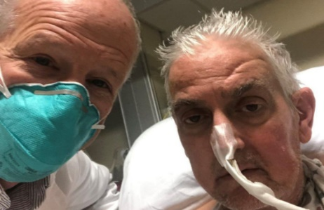

Discussion: How should decisions be made about who should receive scarce organs?
Reflections:
Heavenly Father, For the sake of your loving kindness, may we not be slow to show our compassion by willing to take a further step on organ donation and by that many more others may do likewise. Let not the hope of these patients be taken away and that their will to live may be encouraged and strengthened. Through Christ our Lord. Amen. | “Give yourself and those in need an elixir of life by pledging your organs.”  ― Mohith Agadi
Food Waste
29th September is International Day of Awareness of Food Loss and Waste. The International Day of Awareness of Food Loss and Waste is an opportunity to call to action both the public (national or local authorities) and the private sector (businesses and individuals), to prioritise actions and move ahead with innovation to reduce food loss and waste towards restoring and building back better and resilient-ready, food systems.

True or False?
Statement | T/F? | Statement
The UK produces an estimated 10 million tonnes of food waste each year, |  | 13% of edible food and drink purchased by households are wasted
The hospitality industry wastes an estimated £2.5 billion a year in food waste |  | Food waste costs on average £340 per household per year

Complete the brainstorm:

What steps can a person take to reduce their individual food waste?

Discussion: What can restaurants and supermarkets do to waste less food?
Reflections:
And when they had eaten their fill, he told his disciples, “Gather up the leftover fragments, that nothing may be lost.”  John 6:12 | There are nearly a billion undernourished people in the world– but all of them could be fed with just a fraction of the food that rich countries currently throw away. – Tristram Stuart
Neuro Diversity
October is ADHD Awareness Month. Attention-deficit/hyperactivity disorder (ADHD) is a neurodevelopmental disorder affecting both children and adults around the globe.

Task: True or false?
Statement | T/F? | Statement | T/F?
Males are almost two times more likely to be diagnosed with ADHD than females. |  | The average of ADHD diagnosis is 10 years old.
ADHD isn’t just a childhood disorder. About 2 percent of adults over the age of 18 deal with ADHD on a daily basis. |  | Symptoms of ADHD typically first appear between the ages of 3 and 6

Look at the list of some of the ADHD symptoms – consider how these might impact daily life with friends, family ant at work:
Symptom | Impact on daily life
Impulsiveness
Disorganization
Poor time management
Problems focusing
Restlessness
Low frustration tolerance
Trouble coping with stress

Discussion: what accommodations can we make for peers with ADHD to make life a little easier?
Reflections:
Make strong in our hearts what unites us; Build bridges across all that divides us;  United make us rejoice in our diversity.  And at one in our witness to your peace,  A rainbow to your glory. | Living with ADHD is like being locked in a room with 100 Televisions and 100 Radios all playing. None of them have power buttons so you can turn them off and the door is locked from the outside. –Sarah Young
First Aid
Restart a Heart Day will take place on 16 October 2022. The Resuscitation Council UK along with the British Heart Foundation, British Red Cross, St John Ambulance, NHS Ambulance Service and Saving Lives for Scotland work together to help raise awareness of cardiac arrest and teach CPR.

True or False?

Statement | T/F? | Statement | T/F?
If a defibrillator is used and CPR performed within 3-5 minutes of cardiac arrest the survival rate increases from 6% to 54% |  | 80% of out of hospital cardiac arrests occur at home with the other 20% occurring in public
In the UK 100,000 people die each year from sudden cardiac arrest |  | 170 children die in the UK every year after a cardiac arrest at school

Match the first aid issues to the correct response:

Issue | Response
Bleeding from cut or wound | Run under water for 20mins. Do not pop blisters. Cover.
Large object such as knife or spike embedded | Tilt head forwards. Pinch soft part for 10 mins
Car crash with head injuries | Do not remove as could cause the person to bleed out.
Burn from kitchen | Do not move unless in immediate danger.
Nose bleed | Call emergency services. Give milk to drink.
Poisoning with corrosive liquid | Clean and apply pressure. Dress with sterile dressing.
Choking | Lie on the floor. Raise legs above heart.
Fainting | Back slaps (up to 5), abdominal thrusts (Up to 5) – repeat. Unconscious = CPR.

Discussion:
Reflections:
Almighty God, you lend your strength to all those who are there for us in times of crisis, fear, and hurt. You give courage to the first responders who continue to do this important work they are called to do, looking beyond the risk for the sake of those who need your help and protection. | The first principle of aid is respect. - Author: Ernesto Sirolli

Health
National Stress Awareness Day was set up by the International Stress Management Association, with the mission of raising awareness of the effects of psychological distress in the workplace and strategies to address it.

Task: complete the following brainstorms

Psychological impact of stress

Physical impact of stress

Social impact of stress

Discussion: Do you think you will be more relaxed when you are older? Why do you think so?
Reflections:
Psalms 28:7  "The LORD is my strength and my shield; in him my heart trusts, and I am helped; my heart exults, and with my song I give thanks to him." | “The greatest weapon against stress is our ability to choose one thought over another.”  ―William James

Pets
Human-Animal Relationship Awareness Week was launched in 2016 by the Animals & Society Institute, which is a non-profit scholarly organization whose purpose is to expand knowledge around the relationships between people and animals. In addition, the group seeks to develop resources in the field of study between humans and animals, all while working to prevent cruelty and violence toward animals.

HARA works to improve the lives of animals while advancing the way they are related to and treated by people all over the world. The desire for Human Animal Relationship Awareness Week is to draw attention to the plight of animals, offering education and improved resources to build a better relationship for the future.
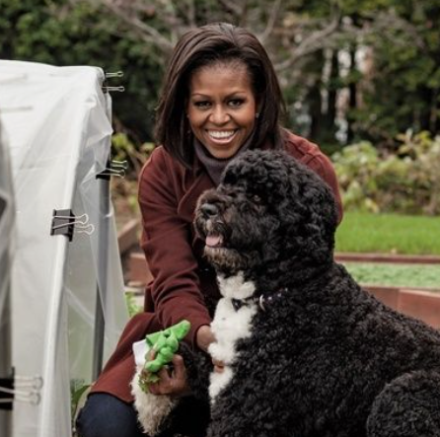
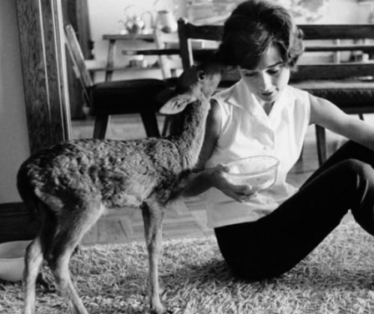
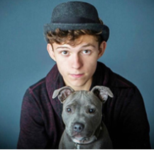
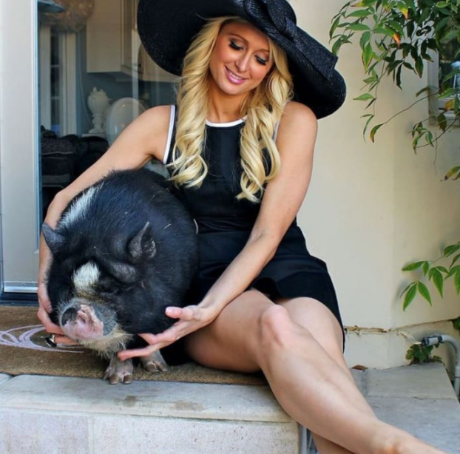
These pets have famous owners – who are they?
Bo the Portuguese Water Dog

Bo the Portuguese Water Dog
Pippin the Deer
Tessa the Staffy
Princess the Pot Bellied Pig

Complete the Brainstorm:

What are the benefits of owning a pet?

Discussion: Got a pet? Tell us about them!
Reflections:
Proverbs 12:10  "A righteous man cares for the needs of his animal." | “Animals are such agreeable friends. They ask no questions; they pass no criticisms.” – George Eliot
Men
International Men's Day is a global holiday celebrated annually on November 19 to recognise and celebrate the cultural, political, and socioeconomic achievements of men.

Task: True or false?

Statement | T/F? | Statement | T/F?
1. On average, c11,900 men die from prostate cancer every year. This is 32 per day, one every 45 minutes) |  | 2. Boys have had worse exam results than girls for 20 years.
3. Men make up 70% of rough sleepers in England. |  | 4. There are around 79,164 people in prison, 96% of whom are male.

Now complete the following brainstorm

Who are the men that you admire or inspired by? Why?

Discussion: Should mum and dads share equality responsibility for raising their kids?
Reflections:
Psalm 37:37  Mark the blameless man, and behold the upright;  For the man of peace will have a posterity. | There is no need for a man to use physical force to show the strength in him, it is a matter of facing the challenges of life without fear.  - Albert Einstein

Food Ethics
The first World Vegan Day was created to mark the 50th anniversary of the society, held on 1 November 1994. This was later extended to become World Vegan Week and, as we now know it, World Vegan Month. Every November, World Vegan Month is celebrated worldwide as a time to shine a light on the vegan diet.

Vegan or not, it is good to know what goes into our food. How much do you know about the packaging?

Task: Look at the symbols and logos below – do you know what they mean in relation to your food?

Logo | Meaning


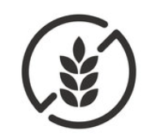
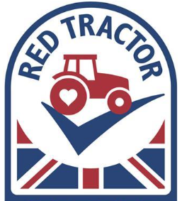




Discussion: Could you be a vegan or vegetarian? Why or Why not?
Reflections:
And God said, “Behold, I have given you every plant yielding seed that is on the face of all the earth, and every tree with seed in its fruit. You shall have them for food.  Genesis 1:29 | Tell me what you eat, and I will tell you who you are.  Jean Anthelme Brillat-Savarin

Charity
December is also known as ‘Decembeard’, a hair-raising campaign organised by Bowel Cancer UK, encouraging men to abandon their razors and grow a beard to raise money and awareness for bowel cancer. Bowel cancer is the UK’s second-biggest cancer killer and more than 44 people die from bowel cancer every day. If detected early, bowel cancer can be treated and cured to help stop it coming back.

Task: Name the owner of the famous beard
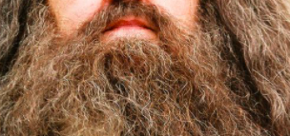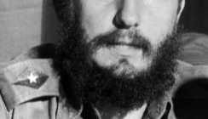

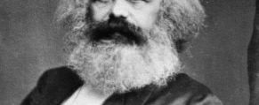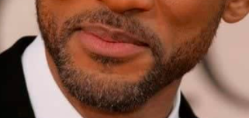
CASE STUDY: Sam Rose.
I was diagnosed with bowel cancer when I was 22 years old. I recall one evening in January that year when I was bleeding all night. I saw my GP and after examining me she said she didn’t know what the cause could be and sent me to hospital instead.
In April, I underwent a procedure known as laparoscopic surgery.
It’s a process that involved surgeons examining my pelvis and the
inside of my abdomen. When the results came back I was told there were
cancerous cells inside the polyp. When they told me the news I was
stunned! I didn’t think it could be cancer.
A colonoscopy I had later showed there were more cancerous cells in
my body. I was told I should have my colon taken out, so I had most of
it removed in August and then an internal pouch created and a colostomy
reversal in January.
I went from being totally healthy and never even having as much as a
broken bone, to racking up experience with so many different medical tests,
hospital treatments and visits.
After having bowel cancer, I had a really good quality of life, and I still do. Having the internal pouch has been brilliant for me and it has worked very well so far.
However, having Lynch syndrome means I have to have regular check-ups. The tests give me horrible anxiety every time, and I’ve had a couple of scares along the way.
In the eight years that followed my bowel cancer, I struggled with health anxiety and grief from what had happened to me, and a fear of the future. The emotional struggle is real, and I think it’s often overlooked.
I have always been a writer and I use writing to deal with my cancer experiences. I think having cancer has made me more grateful for my life and given me a different perspective. People say don’t let cancer change you, but it has changed me, and I am fine with that.

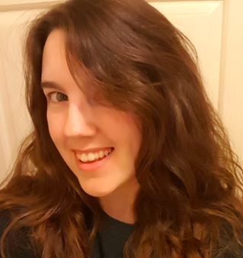

Discussion: Do charitable months with a gimmick work? Should we approach this in a more serious way?
Reflections:
Each one must give as he has decided in his heart, not reluctantly or under compulsion, for God loves a cheerful giver. – 2 Corinthians 9:7 | "We can do no great things, only small things with great love."  -Mother Teresa

Migration
Each year on December 18, the United Nations, through the UN-related agency International Organization for Migration (IOM), uses International Migrants Day to highlight the contributions made by the roughly 272 million migrants, including more than 41 million internally displaced persons, and the challenges they face.

Task: Define these terms
Migrant
Immigrant
Refugee

Push and Pull: Complete the push and pull arrows to show reasons a person would want to migrate, versus reason they would not.

Push Pull

Discussion: What benefits has Migration given to the UK?
Reflections:
Do not forget to show hospitality to strangers, for by so doing some people have shown hospitality to angels without knowing it.  – Hebrews 13:12 | Migration is as natural as breathing, as eating, as sleeping. It is part of life, part of nature. So we have to find a way of establishing a proper kind of scenario for modern migration to exist. And when I say 'we,' I mean the world. We need to find ways of making that migration not forced.  - Gael Garcia Bernal
Christmas in Other Cultures
On Christmas morning, boys and girls around the world will waken early and run excitedly downstairs to see what Santa Claus has left for them...Well, that's not exactly how it goes -- for around the world people celebrate the Christmas holidays in many different ways…
Task: Match the customs to the countries

Christmas is still relatively new. It's only been widely recognized for the past couple of decades, and is typically seen as a time to spread joy and cheer, or even a romantic couple's day, instead of a religious holiday. Many order KFC for Christmas dinner, or make a reservation at a restaurant instead of cooking a big feast. |  | Iceland
Christmas Eve dinner or (Wigilia) begins with sharing the Oplatek. The paper-thin square wafer is made of flour and water has an image of the Nativity on it. Everyone at the table breaks off a piece and shares a holiday greeting before passing it along. Sometimes, even pets get in on the fun. |  | Ethiopia
Decorating Christmas trees and boats has been popular for centuries. The first known Christmas tree in this country was put up by King Otto 1833 next to a large decorated boat, which families traditionally erected to celebrate men's return from sea voyages. |  | Poland
People celebrate Christmas, called Ganna or Genna, on January 7 in accordance with the Orthodox Calendar. Mass often begins with a special candelit procession, in which participants wear a thin white shawl called a Netela and process around the church three times before the service begins. They don't typically give gifts during Ganna; it's a time for church, games and of course, food. |  | Austria
You can do your Christmas shopping with a mug of mulled wine in one hand and a bratwurst in the other at festive outdoor markets. The sprawling seasonal markets pop up all over the country with artisans selling gifts for everyone on your list. |  | Japan
You thought coal in your stocking was bad? Here, St. Nicholas gifts good kids gifts, while Krampus, the half-man, half-goat comes around the drag the bad ones away. In some places, men dress up as the scary character for a Krampuslauf, or “Krampus run" in which they parade through the streets to blow off steam — and scare some kids back into line. |  | Greece
This country has 13 different Santa Clauses, or Yule Lads. Each of these lads has his own different qualities and they can all be a bit feisty. But if good children place their shoes on the windowsill, the Yule Lads will leave them little gifts. If they haven't behaved all year, rotten potatoes show up in their Crocs. |  | Germany

Discussion: What is the most important message we can take from all these Christmas traditions?
Reflections:
Loving Jesus,  you were born in a stable but worshipped by the angels.  Be with all who are lonely,  and with all who feel distant from celebrations.  Be for us a living hope that lightens their hearts.  Amen. | “When we listen and celebrate what is both common and different, we become a wiser, more inclusive, and better organization.” - Pat Wadors
Reflections and Resolutions
A New Year's resolution is a tradition, most common in the Western World but also found in the Eastern World, in which a person resolves to continue good practices, change an undesired trait or behaviour, accomplish a personal goal, or otherwise improve their behaviour.

Task: Guess the top ten new year’s resolutions set each year.

1. | 6.
2. | 7.
3. | 8.
4. | 9.
5. | 10.

Brainstorm: Are there any resolutions you would like to make this year? What steps do you need to implement them?

Ideas for my New Year’s Resolutions

Discussion: Are New Years Resolutions a helpful thing?
Reflections:
As the dawn breaks on a new year, let us give thanks for all we hold dear: our health, our family and our friends. Let us release our grudges, our anger and our pains, for these are nothing but binding chains. Let us live each day in the most loving ways, the God-conscious way. Let us serve all who are in need, regardless of race, colour or creed. Amen | "Although no one can go back and make a brand new start, anyone can start from now and make a brand new ending."  Carl Bard
World Religions
The purpose of World Religion Day is to highlight the ideas that the spiritual principles underlying the world's religions are harmonious, and that religions play a significant role in unifying humanity

Task: Test your knowledge or world religions
Of which country is Taoism a native religion?

What is the meaning of the word ‘Buddha’?

The ‘Torah’ is the sacred book of which religious people?

Who is the Patron Saint of children?

The book of Islamic religion called:

In which religion do men take the last name ‘Singh’ and women ‘Kaur’?

In which religion the Gods Brahma, Vishnu and Siva are worshipped?

What Book of the Bible means “the Going Forth”?

Who was the earliest preacher of Christianity in India?

Which religion, established in India about 500 B.C, has followers who strive for enlightenment?

The members of which Christian sect have no ministers or priests and gather for worship in a Meeting House?

What is the Indigenous religion of Japan?

What was the name of the prophet on whose book Joseph Smith founded the The Church of Jesus Christ of Latter-day Saints?

Discussion: Can all religions coexist happily?
Reflections:
There are doubtless many different languages in the world, and none is without meaning,  1 Corinthians 14:10 | In a civilized society, diversity in religious orientation should be the reason for celebration, not the cause for hatred and differentiation.”  ― Abhijit Naskar

Education
International Day of Education is an annual international observance day held on January 24 and is dedicated to education. On December 3, 2018, the United Nations General Assembly adopted a resolution proclaiming January 24 as International Day of Education, in celebration of the role of education for bringing global peace and sustainable development.

Task: True or false?

Statement | T/F? | Statement | T/F?
Women who are less educated are having more children. |  | 1/4 of the illiterate people in the world are women
43% of the world’s out-of-school children are girls |  | Children living in a rural environment are twice as likely to be out of school than urban children
Brainstorm your thoughts on the following topics

Barriers to a good education

What makes high quality education?

Discussion: What motivates more: good or bad marks? Why?
Reflections:
“Do not forsake wisdom, and she will protect you; love her, and she will watch over you. The beginning of wisdom is this: Get wisdom, though it cost all you have, get understanding” Proverbs 4:6-7 | “If You are planning for a year, sow rice; if you are planning for a decade, plant trees; if you are planning for a lifetime, educate people” – Chinese Proverb
Chinese New Year
Chinese New Year is the festival that celebrates the beginning of a new year on the traditional lunisolar and solar Chinese calendar. In Chinese and other East and Southeast Asian cultures, the festival is commonly referred to as the Spring Festival.
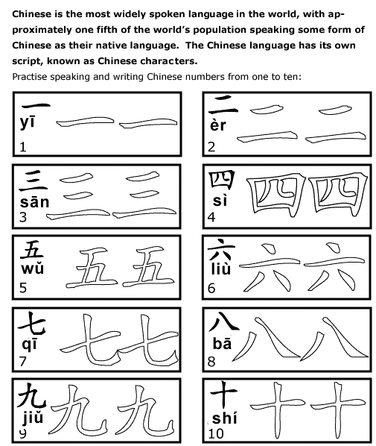

DID YOU KNOW?

The celebration lasts for 15 days ‘til Lantern Festival.

DID YOU KNOW?

One sixth of the world’s people celebrate it.
It is not only celebrated in Mainland China, but also observed in Hong Kong, Taiwan, Vietnam, Singapore and some other Asian countries as well as Chinatowns around the world.

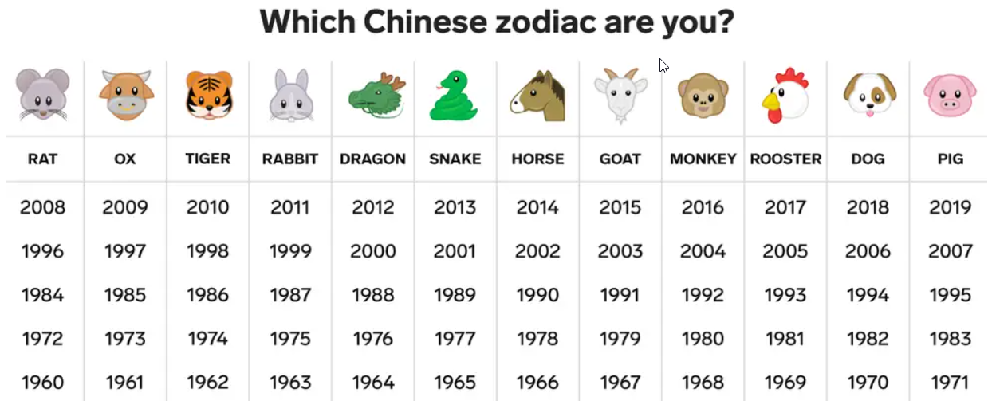
Discussion: How different is Chinese New Year from the international new year?
Reflections:
Dear Heavenly Father, we thank you that in all cultures the New Year means a chance for a fresh start and a new beginning. We pray especially for our Chinese brothers and sisters as they celebrate Chinese New Year. Amen | Virtue is not left to stand alone. He who practises it will have neighbours. - Confucius
Health: Cancer
World Cancer Day is an international day marked on 4 February to raise awareness of cancer and to encourage its prevention, detection, and treatment. World Cancer Day is led by the Union for International Cancer Control to support the goals of the World Cancer Declaration

Task: Brainstorm all the types of cancer you can think of

Types of Cancer

True or false:

Statement | T/F? | Statement | T/F?
There are over 800 new cases of cancer each day in the UK. |  | Half (50%) of people diagnosed with cancer in England and Wales survive their disease for ten years or more
In males in the UK, there are around 193,000 new cancer cases every yea |  | 1 in 2 people in the UK born after 1960 will be diagnosed with some form of cancer during their lifetime.
Alcohol is the largest cause of cancer in the UK, accounting for 15% of all cancer cases. |  | Cancer survival is higher in women than men.

Discussion: How can we help in the fight against cancer?
Reflections:
But those who hope in the LORD will renew their strength. They will soar on wings like eagles; they will run and not grow weary, they will walk and not be faint.  Isaiah 40:31 | “Cancer is a part of our life, but it’s not our whole life.”  — Nick Prochak
Internet Safety
Safer Internet Day is on Tuesday, 11th February; the focus of the day is in creating a “better Internet for all”.

Task: True or false?
Statement | T/F? | Statement | T/F?
Anything I send in private email, IM or chat cannot be seen by others. |  | If I want to know something about a stranger that sends me an IM, I can check their profile and trust that information.
I can always trust emails and attachments I get from friends. |  | The Internet gives us access to many resources we couldn’t otherwise come into contact with.

Your digital footprint:
Annotate the footprint below to show what your online activities say about your. Consider your likes, shares, forwards, follows and images.

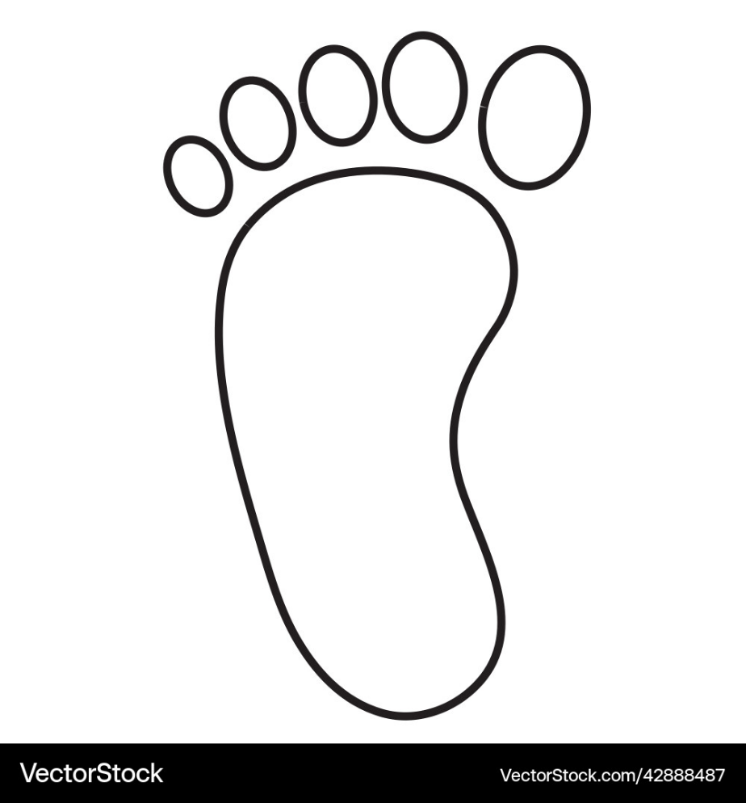

Discussion: What impact does our online behaviour have on us and others?
Reflections:
Proverbs 29:25  Fear of man will prove to be a snare, but whoever trusts in the Lord is kept safe. | Technology is a useful servant, but a dangerous master.  Christian Lous Lange
Discrimination
Zero Discrimination Day is an annual day celebrated on 1 March each year by the United Nations and other international organisations. The day aims to promote equality before the law and in practice throughout all of the member countries of the UN.

Brainstorm:

For what reasons are people discriminated against?

What forms does discrimination take?

True or false:

Statement | T/F? | Statement | T/F?
On average, one in ten people report having suffered ageism when looking for work |  | one in ten (10%) say they have been the subject of gender-based discrimination (12% of women and 7% of men) when applying for jobs
one in twelve feel that they have been on the receiving end of prejudicial treatment because of a disability, their race or sexual orientation (9%, 9% and 8% respectively), at some point in their careers. |  | Half of 18 to 24-year-olds say they have experienced discriminatory attitudes and behaviours at work or during the recruitment process

Discussion: Are the differences between people a reason to celebrate or a source of problems?
Reflections:
Galatians 5:14  For the whole law is fulfilled in one word: “You shall love your neighbour as yourself.” | Racism, xenophobia and unfair discrimination have spawned slavery, when human beings have bought and sold and owned and branded fellow human beings as if they were so many beasts of burden.  - Desmond Tutu
D(d)eafness
World Hearing Day is held on the 3rd March each year to raise awareness on how to prevent deafness and hearing loss and promote ear and hearing care across the world.
We use Deaf with a capital D to refer to people who have been deaf all their lives, or since before they started to learn to talk. They are pre-lingually deaf. It is an important distinction, because Deaf people tend to communicate in sign language as their first language. When we use deaf with a lower case ‘d’ it refers to the physical condition of having hearing loss. People who identify as deaf with a lowercase 'd' don't always have a strong connection to the Deaf community.

Task: True or false?

Statement | T/F? | Statement | T/F?
Globally, over 80% of ear and hearing care needs remain unmet. |  | Your ears don’t stop hearing when you sleep; your brain chooses to ignore the sound.
The number one cause of hearing loss is exposure to excessively loud sounds (85 decibels or higher). |  | You do not need to clean the wax out of your ears unless you have an abnormal condition. Ears push the excess wax out as required.
The roar that we hear when we place a seashell next to our ear is not the ocean but rather the sound of blood surging through the veins in the ear. |  | Currently more than 1.5 billion people (nearly 20% of the global population) live with hearing loss

Now complete the following brainstorm

What challenges might a D/deaf person face, day-to-day?

Discussion: How can we make our local community more accessible for D/deaf people?
Reflections:
Let each of you look not only to his own interests, but also to the interests of others.  Philippians 2:4 | "Hearing loss has often been referred to as an “invisible disability”, not just because of the lack of visible symptoms, but because it has long been stigmatized in communities and ignored by policy-makers."  Tedros Adhanom Ghebreyesus  WHO Director-General
Health
No Smoking Day was first celebrated on Ash Wednesday 1984. It is an annual health awareness day that occurs the second Wednesday of March within the United Kingdom.
Smoking is the single greatest preventable cause of death in the world today. There are more than one billion smokers worldwide- and it kills up to half the people who smoke.

Task: what do we know about smoking?
Why do people smoke?

What does it cost?

What are its effects?

What ways can people stop?

The average UK smoker spends £37.80 per week on cigarettes.
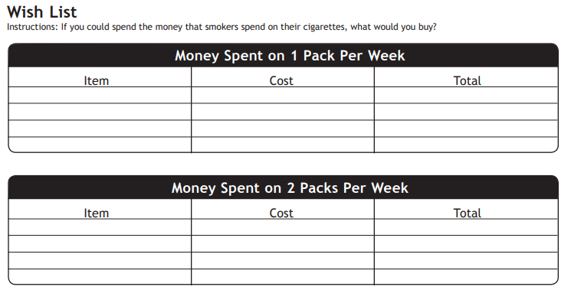
Discussion: Why do people start smoking when we know how dangerous it can be?
Reflections:
1 Corinthians 6:19-20:  Or do you not know that your body is a temple of the Holy Spirit within you, whom you have from God? You are not your own, for you were bought with a price. So glorify God in your body. | Smoking is a custom loathsome to the eye, hateful to the nose, harmful to the brain, dangerous to the lungs, and in the black, stinking fume thereof nearest resembling the horrible Stygian smoke of the pit that is bottomless.  - King James I
Happiness
The International Day of Happiness is celebrated throughout the world on 20 March. It was established by the United Nations General Assembly on 28 June 2012. The International Day of Happiness aims to make people around the world realize the importance of happiness within their lives.

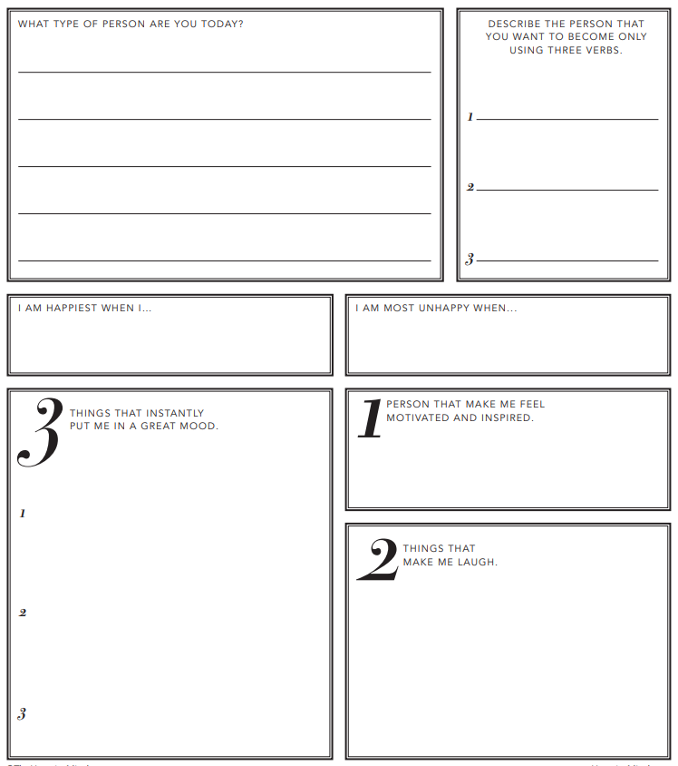

Discussion: What little things could we do to help spread happiness?
Reflections:
Proverbs 16:20  He who heeds the word wisely will find good, and whoever trusts in the LORD, happy is he. | "Let us be grateful to the people who make us happy; they are the charming gardeners who make our souls blossom."  Marcel Proust
Gender Equality
Women's History Month is an annual declared month that highlights the contributions of women to events in history and contemporary society. It is celebrated during March in the United States, the United Kingdom, and Australia, corresponding with International Women's Day on March 8th.

Task: Take the quiz on Women from History

- In 1903, Marie Curie was the first woman awarded a Nobel Prize for her incredible work in what?

- What did activist Rosa Parks do in 1955 to spark the civil rights movement?

- What did the British warrior queen Boudicca famously do?

- What is Rosalind Franklin known for?

- In 1832, who was the first lady to cross the Atlantic solo, in an airplane?

- What is the name of the second female prime minister of the United Kingdom?

- Who was the first woman elected to the Rock and Roll Hall of Fame?

- Which 19th century English woman campaigned for prison reform?

- What is Mother Teresa's given name?

- Who was nicknamed 'The Iron Lady'?

- Teenage Pakistani politician Malala Yousafzai was shot in 2021 for what reason?

- Who was the first woman to reach the summit of Mount Everest?

- Who was the first woman to fly into space?

- In what year did women get to vote in the UK for the first time (if they were over 30)?

Discussion: What barriers still face women today and how can we help to counter these?
Reflections:
Galatians 3:28  There is neither Jew nor Greek, there is neither slave nor free, there is no male and female, for you are all one in Christ Jesus. | “No one can make you feel inferior without your consent.” —Eleanor Roosevelt
Stress
April is recognised as National Stress Awareness Month to bring attention to the negative impact of stress. Managing stress is an essential component of a healthy lifestyle. Knowing how to manage stress can improve mental and physical well-being as well as minimise exacerbation of health-related issues.

Task: Use this template to reflect on your stressors at the moment
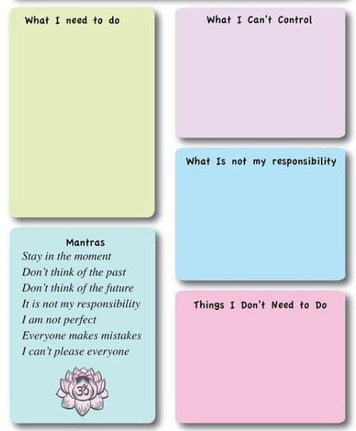

Discussion: What techniques can we use to manage our stress?
Reflections:
Peace I leave with you; my peace I give to you. Not as the world gives do I give to you. Let not your hearts be troubled, neither let them be afraid.  John 14:27 | One of the best pieces of advice I ever got was from a horse master. He told me to go slow to go fast. I think that applies to everything in life. We live as though there aren't enough hours in the day but if we do each thing calmly and carefully we will get it done quicker and with much less stress.  Viggo Mortensen
Chernobyl
International Chernobyl Remembrance Day is on April 27th. The Chernobyl disaster was a nuclear accident that occurred on 26 April 1986 at the No. 4 reactor in the Chernobyl Nuclear Power Plant, near the city of Pripyat in the north of the Ukrainian SSR in the Soviet Union. It is considered the worst nuclear disaster in history both in cost and casualties

True or false:
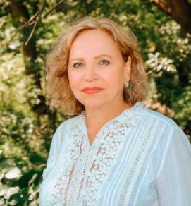
Statement | T/F? | Statement | T/F?
Within three months of the Chernobyl accident, a total of 21 people died from radiation exposure or other direct effects of the disaster |  | The graphite-fuelled fire took 7 days and 150 firefighters to extinguish. However, toxic emissions continued to be pumped into the atmosphere for an additional 10 days.
Shortly after the radiation leaks from Chernobyl occurred, the trees in the woodlands surrounding the plant began to grow rapidly and strangely. This region came to be known as the "Freak Forest". |  | Today, the region, including within the exclusion zone, is filled with a variety of wildlife that have thrived without interference from humans. Thriving populations of wolves, deer, lynx, beaver, eagles, boar, elk, bears and other animals have been documented.
April 26, 1986, started off like any other day for Alla Shapiro. The pediatrician, then 32 years old, learned that an explosion had occurred 80 miles north at the Chernobyl Nuclear Power Plant, just outside the city of Pripyat. In the hours that followed, hundreds of children arrived at the hospital by bus seeking treatment.

What was going through your head as hundreds of children arrived at your hospital for treatment after the Chernobyl explosion?
A panic and in tears. It was a stressful event, but you have to act and do what you have to do. The negative thing was that we didn’t have any instruction, knowledge or training in radiation, so we exercised our [medical] background and did what we could. We also didn't have enough supplies and proper protective clothing to wear during examinations.

Since a similar disaster was never recorded in medical history books, and there were no guidelines in place for how to handle the situation, you had to innovate. Can you give an example of how you improvised?
We tried to comfort the children. It was only much later that we learned the psychological impact. We told them funny stories and hugged them, which worked quite well. And then we looked at what we were facing—if children were coughing, at first we didn’t know why. We soon realized that the cough wasn’t related to any virus or infection. It was because the children were lacking oxygen, and their lungs were plugged with dust that possibly contained radiation particles. There were a lot of mistakes made but one of the biggest was children being left outside to breathe this radioactive air.

Discussion: Is nuclear power a good option today?
Reflections:
“We remember the bombing of Hiroshima and Nagasaki, Chernobyl, Fukushima and other catastrophes, not to open unhealed wounds, but to prevent similar tragedies in the future”  Archbishop Tadeusz Kondrusiewicz | The world has already been overwhelmed by one Chernobyl and one exclusion zone. It cannot afford it anymore. It must learn its lessons from what happened in and around Chernobyl on April 26, 1986. –Serhii Plokhy
Physical Activity
May is Living Streets' National Walking Month when we celebrate the health and happiness benefits of walking more. Walking is one of the easiest ways to improve our health and stay connected to our community, helping us feel less lonely and isolated.

Task: True or false?

Statement | T/F? | Statement | T/F?
The Medicine and Science in Sports and Exercise study found that, on average, adult males took about 5,340 steps per day |  | For general fitness, most adults should aim for 10,000 steps per day,
It requires 100 muscles just to take one step. |  | The longest walk around the world was completed by Jean Beliveau, a neon-sign salesman, who walked 46,600 miles around 64 countries
The average healthy adult walks at a speed of around 4mph. |  | Walking briskly for one mile in 15 minutes burns approximately the same amount of calories as jogging an equal distance in 8.5 minutes.

Now complete the following brainstorm

What are the physical, psychological and social benefits of walking?

Discussion: Where are some good places to go for a walk locally?
Reflections:
Thus says the Lord: “Stand by the roads, and look, and ask for the ancient paths, where the good way is; and walk in it, and find rest for your souls.  Jeremiah 6:16 | “In every walk with nature, one receives far more than he seeks.”  — John Muir
War and Peace
On May 8, 1945, both Great Britain and the United States celebrate Victory in Europe Day. Cities in both nations, as well as formerly occupied cities in Western Europe, put out flags and banners, rejoicing in the defeat of the Nazi war machine during World War II

Task: True or false

Statement | T/F? | Statement | T/F?
50 million people fought in WWII. |  | Great Britain lost 330,000 soldiers in WWII
The Germans' surrender marked the end of WWII in Europe, but Japan didn't surrender until Aug. 15, 1945. |  | Some Japanese soldiers never got the message that the war was over, including Hiroo Onoda. He hid out, fully armed and ready for battle, until 1954 when he was discovered.
Task: Brainstorm the issues which you think are the current causes of war in the world.

Causes of war

Discussion: Can we ever end war forever?
Reflections:
Matthew 5:9  “Blessed are the peacemakers, for they shall be called sons of God.” | “Never think that war, no matter how necessary, nor how justified, is not a crime.”  — Ernest Hemingway, 1946

Vesak
Vesak is one of the most important Buddhist festivals. It is also known as Wesak or Buddha Day.
It is a celebration of Buddha's birthday and a time to reflect on his teachings and what it means to be Buddhist.
Buddhists do not believe in a single god who created the world and everything in it. In fact, most Buddhists believe in the teachings of a man called Siddhartha Gautama - also known as the Buddha. Buddha is a title, rather than a name, which means the enlightened or awakened one.
Buddhists practice 3 things:
- Sila: Virtue, good conduct, morality.
- Samadhi: Concentration, meditation, mental development.
- Prajna: Discernment, insight, wisdom, enlightenment.
Explore the facts about Vesak below, see if you can find links with other world religions
Facts about Vesak | Similarities with other religions
The date of Vesak changes each year as it take places at the time of the first full moon of the ancient lunar month of Vesakha, which usually falls in May or early June.
Many will do good deeds
People take part in chanting and meditation
bring offerings to the temple and share food with people
Families may decorate their homes with lanterns
Some people wear special white clothes to mark the occasion.
A ceremony called Bathing the Buddha may also be held, when water is poured over the shoulders of the Buddha to remind people to clear their minds of negative thoughts like greed and hatred

Discussion: Buddhism is non-violent. However there is still violence in Buddhist countries. What's going on here?
Reflections:
1 Corinthians 14:10  There are doubtless many different languages in the world, and none is without meaning, | We are shaped by our thoughts; we become what we think. When the mind is pure, joy follows like a shadow that never leaves.  - Buddha
Culture
Held every year on 21 May, UNESCO leads the celebration of World Day for Cultural Diversity for Dialogue and Development highlighting not only the richness of the world’s cultures, but also the essential role of intercultural dialogue for achieving peace and sustainable development.
With 89% of all current conflicts in the world occurring in countries with low intercultural dialogue, to forge effective cooperation and sustain peace, strengthening intercultural dialogue must be a priority.

Task: True or false?

Statement | T/F? | Statement | T/F?
Blowing your nose loudly in Japan is rude. |  | In some Asian countries, slurping loudly is a sign that the food is good.
Standing your chopsticks in your food is considered bad luck in China as it looks similar to incense used in funerals |  | Spanish culture has a different timetable to many other places in Europe. It is typical to have lunch between 1-3pm and dinner as late as 10pm!

Now complete the following brainstorm

What cultures are represented within our building, and what do we know about them?

Discussion: What is the difference between cultural appropriation and appreciation?
Reflections:
For life is more than food, and the body more than clothing.  Luke 12:23 | Culture makes people understand each other better. And if they understand each other better in their soul, it is easier to overcome the economic and political barriers. But first they have to understand that their neighbour is, in the end, just like them, with the same problems, the same questions.  Paulo Coelho
Environment
8th June is World Oceans Day. The purpose of the day is to inform the public of the impact of human actions on the ocean, develop a worldwide movement of citizens for the ocean, and mobilize and unite the world’s population on a project for the sustainable management of the world's oceans.

Task: True or false

Statement | T/F? | Statement | T/F?
An estimated 6 Million tons of plastic enters our oceans every year. |  | By 20700, the pollution of fish will be outnumbered by our dumped plastics
70% of our debris sinks into the ocean's ecosystem |  | Plastic bags are illegal in Kenya. People found using, selling, or manufacturing them risk 4 years of incarceration and a $40,000 fine.
Ocean crusaders estimate there to be 26,000 plastic pieces in our waters per mile (squared) |  | 60% of pollution in our oceans comes from land-based sources.
In various studies, plastics made up 60-90% of the marine pollution found |  | 80% of global marine pollution comes from agriculture runoff, untreated sewage, discharge of nutrients and pesticides.
Task: Swaps – what alternatives could you choose in order to reduce pollution in our oceans?
Original | Alternative(s)
Plastic Straws
Bottled water
Plastic Shopping Bags

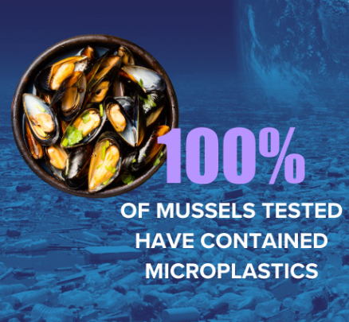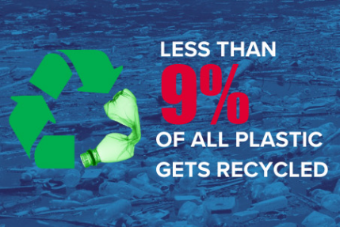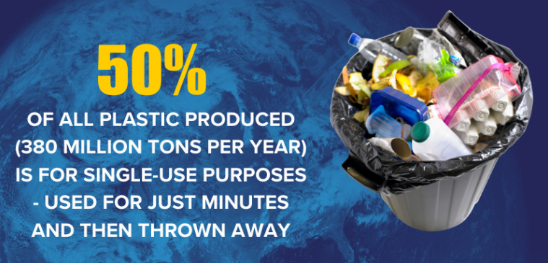

Discussion: Who bears responsibility for plastic pollution in our oceans?
Reflections:
Psalm 104:25  There is the sea, great and broad,  In which are swarms without number,  Animals both small and great. | "I hope for your help to explore and protect the wild ocean in ways that will restore the health and, in so doing, secure hope for humankind. Health to the ocean means health for us."  - Sylvia Earle, Oceanographer
Child Labour
12th June is World Day Against Child Labour. Children around the world are routinely engaged in paid and unpaid forms of work that are not harmful to them. However, they are classified as child labourers when they are either too young to work, or are involved in hazardous activities that may compromise their physical, mental, social or educational development.

Task: Complete the following lists

Types of child labour | Reasons child labour happens | Impact on the children in labour

Task: : True or false

Statement | T/F? | Statement | T/F?
The number of children in child labour has risen to 100 million worldwide |  | Child labour in rural areas stands at 14%, nearly three times higher than the 5% in urban areas.
The agriculture sector accounts for 50% of children in child labour |  | In the least developed countries, slightly more than one in ten children (ages 5 to 17) are engaged in labour that is considered detrimental to their health and development.

Discussion: How can we make more ethical consumer choices to help fight child labour
Reflections:
Matthew 19:14  But Jesus said, “Let the little children come to me and do not hinder them, for to such belongs the kingdom of heaven.” | "Child labour and poverty are inevitably bound together and if you continue to use the labor of children as the treatment for the social disease of poverty, you will have both poverty and child labour to the end of time" - Grace Abbott

Windrush
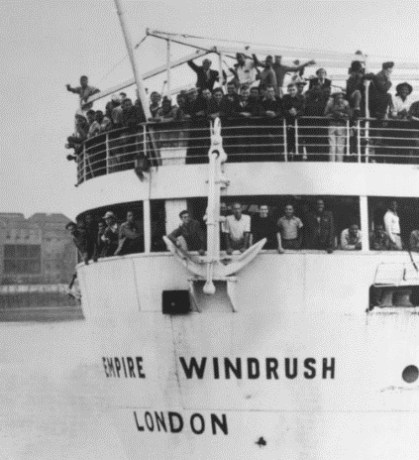
22nd June is Windrush Day. The day marks the arrival of Afro-Caribbean immigrants to the shores of Britain and honours the British Caribbean community. An estimated half a million people made their way to England after the Second World War. Many of the children who arrived in the UK travelled on their parents’ passports. After 50 years of living in the UK, many do not and never applied for a British passport. This later became a problem as changes in immigration law in 2012 meant that documentation was required to work, rent property, receive benefits and obtain healthcare.

Task: Take this quiz!

1. Which year did the Empire Windrush arrive in Britain?
2. Where in Britain did the Empire Windrush dock?
3. Where had the Empire Windrush come from?
4. How long (in feet) was the Empire Windrush?
5. Which famous annual street event was founded by members of the Windrush Generation?
6. Which member of the House of Lords travelled to the UK from the Caribbean as a young girl and made her name in children’s television?
7. Why did people travel from their homes in the Caribbean to Britain?
8. How much did it cost to travel abroad the Empire Windrush?
9. Passengers onboard the Windrush were asked to provide their last country of residence. Which country was listed the most?
10. How many passengers were on board the Empire Windrush?

Discussion: Has UK society changed? Is it more hostile to foreigners?
Reflections:
Leviticus 19:33-34  “When a stranger sojourns with you in your land, you shall not do him wrong. You shall treat the stranger who sojourns with you as the native among you, and you shall love him as yourself, for you were strangers in the land of Egypt: I am the Lord your God | “Sometimes I can be walking down the street, or riding a bus, and suddenly I see somebody who remind me of somebody I know back home, and I close my eyes and find myself thinking of the sea, or the taste of grafted mango, or the smell of saltfish frying, and then I come back to myself and open my eyes and realise where I am.”  ― Caryl Phillips, In the Falling Snow
Roma
June is Gypsy Roma Traveller History Month. Through celebration, education and raising awareness, Gypsy, Roma and Traveller History Month helps to tackle prejudice, challenge myths and to amplify the voices of Gypsies, Roma and Travellers in wider society.

Task: Put these sentences back together!

The Romani people migrated |  | They typically adopt the spiritual beliefs of whatever country they have migrated to - for example, there are Catholic, Muslim, and even Baptist Roma
During WWII in Germany and Nazi-controlled countries, the Roma were commonly persecuted |  | Rather than writing down their history, the group tells stories to pass on important cultural information to future generations.
The Romani people do not practice a singular religion that is shared across their entire culture. |  | from India 1,500 Years Ago
The United Nations Development Program described the Roma as the most economically vulnerable population on the continent of Europe |  | English slang words like posh, shiv, dukes, and pal all have their origins in the Romani language.
One cultural tradition of the Roma people that has remained unchanged is their reliance on oral history and storytelling. |  | and showed that they often lacked access to basic education, health, and other social benefits.
The language (Rromanës) also did not have a standard alphabet until 1990, as the Romani culture has traditionally relied solely on oral communication. |  | for being "racially inferior" because of their traditions and beliefs

There are many different dialects of Romani spoken in England alone. The language is historically fluid, adapting with location and between families.

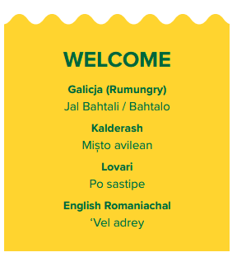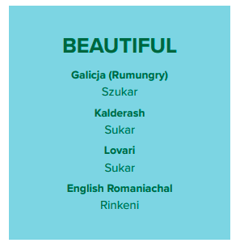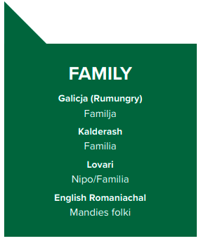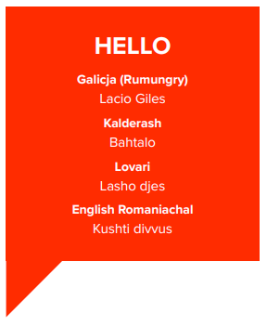

Discussion: Should the government provide more official places for nomadic people to stop?
Reflections:
Ephesians 4:32  Be kind to one another, tenderhearted, forgiving one another, as God in Christ forgave you. | We are all wanderers on this earth. Our hearts are full of wonder, and our souls are deep with dreams.  Romany Gypsy Proverb
Fair Trade
7th July is World Chocolate Day. It is an annual celebration of chocolate, occurring globally, which some suggest to be the anniversary of the introduction of chocolate to Europe in 1550. Fair trade is an arrangement designed to help producers in growing countries achieve sustainable and equitable trade relationships. The fair trade movement combines the payment of higher prices to exporters with improved social and environmental standards.

Task: Answer these questions
What do you know about Fairtrade?
Is it a good idea?
Do you buy Fairtrade?

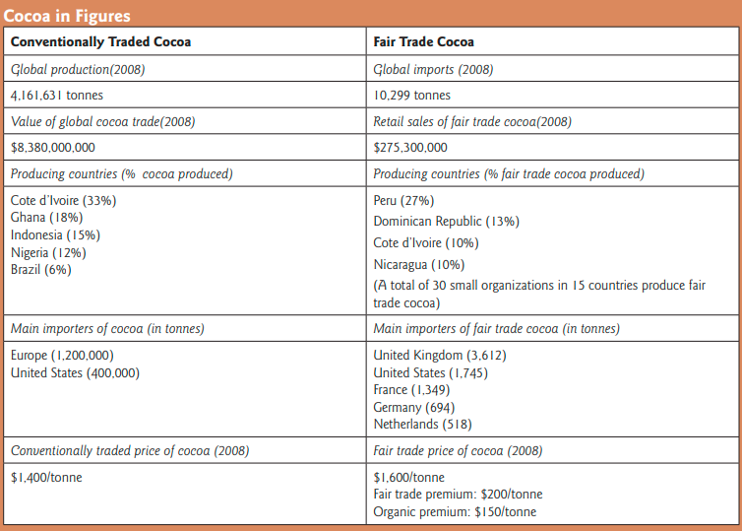
Examine the economic differences between the countries that produce cocoa and those that import/purchase.

Discussion: Why is it important to consider where and how cocoa and chocolate are made and sold?
Reflections:
Proverbs 11:1  A false balance is an abomination to the Lord, but a just weight is his delight | I pity the man who wants a coat so cheap that the man or woman who produces the cloth will starve in the process.  Benjamin Harrison
Population
11th July is World Population Day. It seeks to focus attention on the urgency and importance of population issues, and was established in 1989. The day was created from the outgrowth of the interest generated by the Day of Five Billion (people on the planet), which was observed on 11 July 1987.

Task: True or False?
Statement | T/F? | Statement | T/F?
The world’s population is growing by an additional 53 million people annually. |  | 50.4 percent of the world’s population is male and 49.6 percent is female.
The global population is expected to reach 7.6 billion in 2030 |  | More than three-quarters of the world’s population lives in Africa (17 percent) and Asia (60 percent)
Indigenous peoples account for around 5 percent of the world’s population but 15 percent of people living in poverty |  | The world’s population aged 60 or above is growing at a rate of 1.5 percent per year

Task: Brainstorm methods of population control – explain why they might or might not work, highlight any ethical issues

Methods of Population Control.

Discussion: Should more measures be taken to control the global population?
Reflections:
Genesis 1:28  And God blessed them. And God said to them, “Be fruitful and multiply and fill the earth and subdue it and have dominion over the fish of the sea and over the birds of the heavens and over every living thing that moves on the earth.” | The key problem facing humanity in the coming century is how to bring a better quality of life — for 8 billion or more people — without wrecking the environment entirely in the attempt.  ~ Edward O. Wilson, scientist
Communication
World Emoji Day is celebrated on July 17 each year. It was created by Jeremy Burge, the founder of Emojipedia. The significance of World Emoji Day lies in celebrating the universal language of emojis and their ability to convey emotions, ideas, and messages across different cultures and languages. Emojis have become an integral part of modern communication, adding a playful and expressive element to text-based conversations.

Task: Work out the place from the emoji below.
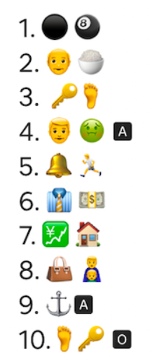

Now complete the following brainstorm

How do you communicate with others – consider the strengths and limitations of each method.

Discussion: How do you predict communication will evolve in the next 10 years?
Reflections:
Proverbs 15:2  The tongue of the wise commends knowledge, but the mouths of fools pour out folly. | We have two ears and one mouth so that we can listen twice as much as we speak.  Epictetus
Self Care
24th June marks the start of Self-Care Month, which ends with Self-Care Day on 24 July. This symbolic day was chosen because self-care can be practiced “24 hours a day/7 days a week”.
Self-Care Month is an opportunity to raise additional awareness about self-care and self-care interventions and celebrate the benefits that they bring to people’s lives and what’s been achieved so far

Task: What are the factors that can influence our wellbeing?

Wellbeing influences

Discuss and compile a list of 10 things you could do to care for yourself:
1
2
3
4
5
6
7
8
9
10

Discussion: What organisations and groups could we access to support our self-care and wellbeing?
Reflections:
Come to me, all who labor and are heavy laden, and I will give you rest. Take my yoke upon you, and learn from me, for I am gentle and lowly in heart, and you will find rest for your souls. For my yoke is easy, and my burden is light.”  Matthew 11:28-30 | “Love yourself enough to set boundaries. Your time and energy are precious. You get to choose how you use it. You teach people how to treat you by deciding what you will and won’t accept.”  Anna Taylor
Answers:
- Mental Health: All the statements are true!
- Democracy

Down:
1. Constitution
2. Society
3. Democracy
5. Parliament

Across:
4. Dictatorship
6. Minister
7. Election
8. Monarchy
9. Vote
10. Constituency
- Organ Donation:
Statement | T/F? | Statement | T/F?
Right now across the UK, there are around 4,500 people in need of an organ transplant | F – its 6,500 | The kidney is the most commonly transplanted organ in the world | T
In the UK there are around 150 children and teenagers in need of a transplant | T | There is a shortage of organ donors for and from black and ethnic minority groups. | T
- Food Waste
Statement | T/F? | Statement
The UK produces an estimated 10 million tonnes of food waste each year, | F- Its 14! | 13% of edible food and drink purchased by households are wasted | T
The hospitality industry wastes an estimated £2.5 billion a year in food waste | T | Food waste costs on average £340 per household per year | F- its £540

- Neuro Diversity:
Statement | T/F? | Statement | T/F?
Males are almost two times more likely to be diagnosed with ADHD than females. | F- its three times | The average of ADHD diagnosis is 10 years old. | F – Its 7
ADHD isn’t just a childhood disorder. About 2 percent of adults over the age of 18 deal with ADHD on a daily basis. | F- its 4% | Symptoms of ADHD typically first appear between the ages of 3 and 6 | T

- First Aid
Statement | T/F? | Statement | T/F?
If a defibrillator is used and CPR performed within 3-5 minutes of cardiac arrest the survival rate increases from 6% to 54% | F- its 74% | 80% of out of hospital cardiac arrests occur at home with the other 20% occurring in public | T
In the UK 100,000 people die each year from sudden cardiac arrest | T | 170 children die in the UK every year after a cardiac arrest at school | F- it is 270

Issue | Response
Bleeding from cut or wound | Clean and apply pressure. Dress with sterile dressing.
Large object such as knife or spike embedded | Do not remove as could cause the person to bleed out.
Car crash with head injuries | Do not move unless in immediate danger.
Burn from kitchen | Run under water for 20mins. Do not pop blisters. Cover.
Nose bleed | Tilt head forwards. Pinch soft part for 10 mins
Poisoning with corrosive liquid | Call emergency services. Give milk to drink.
Choking | Back slaps (up to 5), abdominal thrusts (Up to 5) – repeat. Unconscious = CPR.
Fainting | Lie on the floor. Raise legs above heart.
- Health – Stress
- Pets
Princess the Pot Bellied Pig – Paris Hilton | Pippin the Deer – Audrey Hepburn | Tessa the Staffy – Tom Holland | Bo the Portuguese Water Dog – The Obamas
- Men
Statement | T/F? | Statement | T/F?
1. On average, c11,900 men die from prostate cancer every year. This is 32 per day, one every 45 minutes) | T | 2. Boys have had worse exam results than girls for 20 years. | F- Its 30 years
3. Men make up 70% of rough sleepers in England. | F- Its 85% | 4. There are around 79,164 people in prison, 96% of whom are male. | T
- Food Ethics
Logo | Meaning
 | Food is vegetarian – it does not contain any meat product or gelatine
 | Vegan – has no animal derived products including egg, dairy or honey.
 | Gluten Free – no wheat products are in this food. This is important for people with a gluten allergy or Coeliac disease.
 | The food you buy has been responsibly sourced, safely produced and comes from crops and animals that have been well cared for – so it's good for you and good for British farmers.
 | The Marine Stewardship Council or “MSC” label is a symbol of sustainability, wherein all brands that earn the label are committed to the betterment of our ocean's populations. The label is only granted to those companies whom work actively towards the sustainability of our earth's oceans
 | Organic soil – this product was grown with organic soil.
 | Fair trade - fairly produced and fairly traded products. It also means the product is fully traceable (kept separate from non-certified products) from farm to shelf. You see this Mark on single-ingredient products, such as bananas and coffee.

- Charity:
Beards from Left to right – Hagrid, Jason Momoa, Fidel Castro, Karl Marx, Dave Grohl, Will Smith

- Migration:
Migrant | a person who has left their home country in order to find work or better living conditions.
Immigrant | a person in a country who was not born there. This can be done legally or illegally.
Refugee | a person who has had to leave their home or country due to war, persecution or disaster.

- Christmas in other cultures:
- Japan | - Poland
- Greece | - Ethiopia
- Germany | - Austria
- Iceland

- Resolutions
1. Loose weight | 6. Sort out finances and cut back spending
2. Eat healthier | 7. Travel more
3. Get fitter | 8. Take up a new hobby, sport or other interest
4. Spend more time with family/friends | 9. Be more environmentally friendly
5. Be more aware and take care of mental health | 10. Look for a new job
- World Religions:
Of which country is Taoism a native religion?
Answer: China.
What is the meaning of the word ‘Buddha’?
Answer: Enlightened one.
The ‘Torah’ is the sacred book of which religious people?
Answer: The Jews.
Who is the Patron Saint of children?
Answer: Saint Nicholas.
The book of Islamic religion called:
Answer: The Quran.
In which religion do men take the last name ‘Singh’ and women ‘Kaur’?
Answer: Sikhism.
In which religion the Gods Brahma, Vishnu and Siva are worshipped?
Answer: Hinduism.
What Book of the Bible means “the Going Forth”?
Answer: Exodus.
Who was the earliest preacher of Christianity in India?
Answer: Saint Thomas.
Which religion, established in India about 500 B.C, has followers who strive for enlightenment?
Answer: Buddhism.
The members of which Christian sect have no ministers or priests and gather for worship in a Meeting House?
Answer: Quakers (Society of Friends).
What is the Indigenous religion of Japan?
Answer: Shinto.
What was the name of the prophet on whose book Joseph Smith founded the The Church of Jesus Christ of Latter-day Saints?
Answer: Mormon.

- Education
Statement | T/F? | Statement | T/F?
Women who are less educated are having more children. | T | 1/4 of the illiterate people in the world are women | F- It is 2/3
43% of the world’s out-of-school children are girls | F- it is 53% | Children living in a rural environment are twice as likely to be out of school than urban children | T
- Chinese New Year
- Cancer
Statement | T/F? | Statement | T/F?
There are over 800 new cases of cancer each day in the UK. | F – It is 1000 | Half (50%) of people diagnosed with cancer in England and Wales survive their disease for ten years or more | T
In males in the UK, there are around 193,000 new cancer cases every yea | T | 1 in 2 people in the UK born after 1960 will be diagnosed with some form of cancer during their lifetime. | T
Alcohol is the largest cause of cancer in the UK, accounting for 15% of all cancer cases. | F- it is smoking | Cancer survival is higher in women than men. | T

- Safer Internet Day
Statement | T/F? | Statement | T/F?
Anything I send in private email, IM or chat cannot be seen by others. | F | If I want to know something about a stranger that sends me an IM, I can check their profile and trust that information. | F
I can always trust emails and attachments I get from friends. | F | The Internet gives us access to many resources we couldn’t otherwise come into contact with. | T

- Discrimination
Statement | T/F? | Statement | T/F?
On average, one in ten people report having suffered ageism when looking for work | F – it is one in six | one in ten (10%) say they have been the subject of gender-based discrimination (12% of women and 7% of men) when applying for jobs | T
one in twelve feel that they have been on the receiving end of prejudicial treatment because of a disability, their race or sexual orientation (9%, 9% and 8% respectively), at some point in their careers. | T | Half of 18 to 24-year-olds say they have experienced discriminatory attitudes and behaviours at work or during the recruitment process | F – it is three quarters
- D(d)eafness
True or False: All are true!
- Health
- Happiness
- Gender Equality

  - Radiation
  - Refused to give up her seat on a bus to a white person
  - Led revolts against Roman rule
  - Rosalind Franklin is known for an X-ray diffraction image that led to the discovery of the DNA double helix
  - Amelia Earhart
  - Theresa May
  - Aretha Franklin
  - Elizabeth Fry
  - Agnes
  - Margret Thatcher
  - Writing a blog about girls' right to an education
  - Junko Tabei
  - Valentina Tereshkova
  - 1918

- Stress

- Chernobyl
True or false:

Statement | T/F? | Statement | T/F?
Within three months of the Chernobyl accident, a total of 21 people died from radiation exposure or other direct effects of the disaster | F – it was 31 | The graphite-fuelled fire took 7 days and 150 firefighters to extinguish. However, toxic emissions continued to be pumped into the atmosphere for an additional 10 days. | 10 days, 250 firefighters
Shortly after the radiation leaks from Chernobyl occurred, the trees in the woodlands surrounding the plant began to grow rapidly and strangely. This region came to be known as the "Freak Forest". | F- the trees were killed by radiation and was known as the "Red Forest". | Today, the region, including within the exclusion zone, is filled with a variety of wildlife that have thrived without interference from humans. Thriving populations of wolves, deer, lynx, beaver, eagles, boar, elk, bears and other animals have been documented. | T
- Physical Activity
Statement | T/F? | Statement | T/F?
The Medicine and Science in Sports and Exercise study found that, on average, adult males took about 5,340 steps per day | T | For general fitness, most adults should aim for 10,000 steps per day, | T
It requires 100 muscles just to take one step. | F – It’s 200 | The longest walk around the world was completed by Jean Beliveau, a neon-sign salesman, who walked 46,600 miles around 64 countries | T
The average healthy adult walks at a speed of around 4mph. | F – Its 3mph | Walking briskly for one mile in 15 minutes burns approximately the same amount of calories as jogging an equal distance in 8.5 minutes. | T

- War and Peace
Statement | T/F? | Statement | T/F?
50 million people fought in WWII. | F – it was 70 million | Great Britain lost 330,000 soldiers in WWII | T
The Germans' surrender marked the end of WWII in Europe, but Japan didn't surrender until Aug. 15, 1945. | T | Some Japanese soldiers never got the message that the war was over, including Hiroo Onoda. He hid out, fully armed and ready for battle, until 1954 when he was discovered. | F – it was 1974
- Vesak
- Culture
Statement | T/F? | Statement | T/F?
An estimated 6 Million tons of plastic enters our oceans every year. | F – its 8mil | By 20700, the pollution of fish will be outnumbered by our dumped plastics | F – its 2050
70% of our debris sinks into the ocean's ecosystem | T | Plastic bags are illegal in Kenya. People found using, selling, or manufacturing them risk 4 years of incarceration and a $40,000 fine. | T
Ocean crusaders estimate there to be 26,000 plastic pieces in our waters per mile (squared) | F - Its 46000 | 60% of pollution in our oceans comes from land-based sources. | F – its 80%
In various studies, plastics made up 60-90% of the marine pollution found | T | 80% of global marine pollution comes from agriculture runoff, untreated sewage, discharge of nutrients and pesticides. | T
True or False: All are true!
- Environment: Oceans

- Child Labour
Statement | T/F? | Statement | T/F?
The number of children in child labour has risen to 100 million worldwide | F – its 160mil | Child labour in rural areas stands at 14%, nearly three times higher than the 5% in urban areas. | T
The agriculture sector accounts for 50% of children in child labour | F – its 70% | In the least developed countries, slightly more than one in ten children (ages 5 to 17) are engaged in labour that is considered detrimental to their health and development. | F – its 1 in 4
- WindRush
1.1948 2. Port of Tilbury, Essex 3. Jamaica 4. 500ft 5. Notting Hill Carnival 6. Floella Benjamin 7. For work – The British Government invited them to Britain after the end of the SWW to help address labour shortages 8.£28 (about £1,000 today) 9.Jamaica – 539 passengers listed Jamacia as their previous residence 10.1,027

- Roma
The Romani people migrated |  | They typically adopt the spiritual beliefs of whatever country they have migrated to - for example, there are Catholic, Muslim, and even Baptist Roma
During WWII in Germany and Nazi-controlled countries, the Roma were commonly persecuted |  | Rather than writing down their history, the group tells stories to pass on important cultural information to future generations.
The Romani people do not practice a singular religion that is shared across their entire culture. |  | from India 1,500 Years Ago
The United Nations Development Program described the Roma as the most economically vulnerable population on the continent of Europe |  | English slang words like posh, shiv, dukes, and pal all have their origins in the Romani language.
One cultural tradition of the Roma people that has remained unchanged is their reliance on oral history and storytelling. |  | and showed that they often lacked access to basic education, health, and other social benefits.
The language (Rromanës) also did not have a standard alphabet until 1990, as the Romani culture has traditionally relied solely on oral communication. |  | for being "racially inferior" because of their traditions and beliefs
- Fair Trade
- Population
Statement | T/F? | Statement | T/F?
The world’s population is growing by an additional 53 million people annually. | F – its 83 mil | 50.4 percent of the world’s population is male and 49.6 percent is female. | T
The global population is expected to reach 7.6 billion in 2030 | F – Its 8.6 billion | More than three-quarters of the world’s population lives in Africa (17 percent) and Asia (60 percent) | T
Indigenous peoples account for around 5 percent of the world’s population but 15 percent of people living in poverty | T | The world’s population aged 60 or above is growing at a rate of 1.5 percent per year | F – its 3%
- Communication
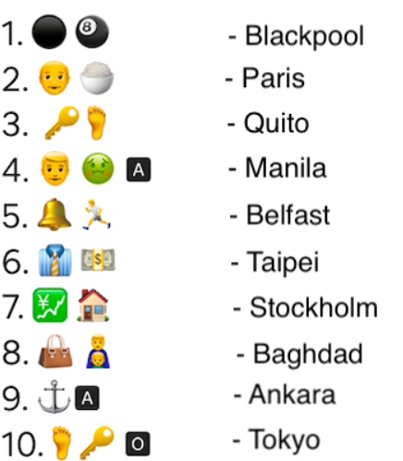
- Self care

